**Heredity and Evolution**

# Heredity and Variation

* Living organisms have certain recognizable heritable features such as height, complexion, color of hair and eyes, shape of nose and chin etc. These are called **characters**.
* The alternative forms of a character are called **traits**. The inheritable characteristics or traits may be morphological, anatomical, physiological or reproductive.
* The transmission or passing of genetically based characters or traits from the parents to their offspring is called **heredity**.
* The occurrence of small differences or changes among the individuals of a species is called **variation**. Hereditary variations are of great importance in the process of **evolution** of a new species.
* Asexual reproduction results in a small amount of variation as compared to sexual reproduction.
* **Genes** are the specific parts of chromosomes or deoxyribonucleic acid (DNA) segments which determine hereditary characteristics.
* Every gene has two alternative forms for a character, each of which produces different effects in an organism. These alternative forms are called **alleles**. Example: In case of pea plants, the stem height is controlled by two alleles—one for tallness and the other for dwarfness.
* Of the two alleles of a gene, one is dominant, i.e. super ruling and the other is recessive, i.e. subordinate or submissive. A **dominant** allele is the allele which hides or masks the expression of its corresponding allele, which in turn becomes **recessive**.
* A contrasting pair of alleles constitutes an **allelomorph**.
* The genetic constitution of an organism is called its **genotype**. It is the description of genes present in an organism. The genotype of a tall plant could be TT or Tt, while that of a dwarf plant is tt.
* **Phenotype** refers to the observable characteristics or the expressed shown character of an organism. Example: Tall and dwarf are the phenotypes of a plant because these traits are visible to us.
* When two parents are crossed to produce progeny, their progeny is called the **first filial generation**

or **F1 generation**.

* When the first-generation progeny or F1 progeny is crossed amongst themselves to produce a second-generation progeny, this progeny is called the **second filial generation** or **F2 generation**.
* A new form of plant resulting from a cross of different varieties of a plant is known as a **hybrid**.

# Rules for Inheritance of Traits

* **Mendel** conducted experiments on pea plants (***Pisum sativum***) and studied the inheritance of certain traits.

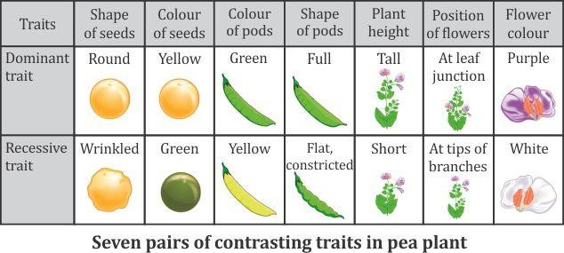

* A cross which involves only a single pair of contrasting characters is called a **monohybrid cross**. Example: A cross between a tall pea plant (TT) and a dwarf pea plant (tt).

**Phenotypic ratio:** 3 : 1

**Genotypic ratio:** 1 : 2 : 1

* The results of the monohybrid cross enabled Mendel to formulate his first law of inheritance, which is called the **law of segregation**. It states that- ‘The characteristics or traits of an organism are determined by internal factors, which occur in pairs. Only one of a pair of such factors can be present in a single gamete’.
* A cross which involves plants with two pairs of contrasting characters is called a **dihybrid cross**. Example: A cross of pea plants having round and yellow seeds (RRYY) and plants with wrinkled and green seeds (rryy).

**Phenotypic ratio:** 9 : 3 : 3 : 1

**Genotypic ratio:** 1 : 4 : 1 : 1 : 1 :2 : 2 : 2 : 2

* The results of the dihybrid cross enabled Mendel to formulate his second law of inheritance, which is called the **law of independent assortment**. It states that- ‘In the inheritance of more than one pair of traits in a cross simultaneously, the factors responsible for each pair of traits are distributed independently to the gametes’.
  + **DNA** (Deoxyribonucleic acid) is a highly complex molecule with a spirally coiled, double helical structure which appears like a ladder.

## Differences between Inherited and Acquired Traits

|  |  |
| --- | --- |
| **INHERITED TRAITS** | **ACQUIRED TRAITS** |
| 1. Characteristics inherited from the previous  generation. | 1. Characteristics which develop in response to  the environment and cannot be inherited. |
| 2. Occur due to a change in genes or DNA. | 2. No change in genes or DNA is involved. |
| 3. Pass on from one generation to another. | 3. Cannot pass on from one generation to  another. |
| 4. Examples: Red curly hair, brown eyes | 4. Examples: Cycling, swimming |

**Sex Determination**

* + The phenomenon or process which determines whether a developing embryo will be a male or a female is known as **sex determination**.
  + In most organisms, **environmental** and **genetic** or **chromosomal** mechanisms are mainly responsible for the determination of sex of an individual.
  + Humans have 22 pairs of **autosomes** and 1 pair of **sex chromosome**.
  + **Females** have similar sex chromosomes **XX**, whereas **males** have a dissimilar pair, i.e. **XY**. All eggs carry the X chromosome, while sperms may either carry an X or a Y chromosome.
  + The sex of a child depends on whether the egg fuses with the sperm carrying an X chromosome (resulting in a **female**) or with the sperm carrying a Y chromosome (resulting in a **male**).

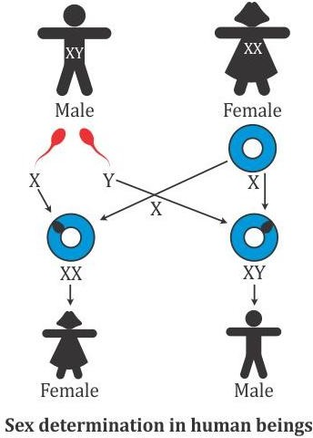

# Evolution

* + **Evolution** can be defined as the formation of more complex organisms from pre-existing simpler organisms over a certain period. It is a slow, but progressive, natural, sequential development or transformation of animals and plants from ancestors of different forms and functions.
  + Variation and **heredity** are the two basic factors of evolution. The selection of variants by environmental factors forms the basis of evolutionary processes.

## Evidences for Evolution

* + A large amount of information has been collected over the last 200 years to support the theory of organic evolution. Such supporting information which helps us in accepting the theory is called **evidence**.

|  |  |
| --- | --- |
| **Morphological Evidence** | * Morphological evidence of evolution reflects in the form of external features   or the appearance of an organism. |
| **Anatomical Evidence** | * Anatomical evidence of evolution is usually reflected in the form of structures, which appear quite similar in their organisation. * The similarities found in different groups of organisms indicate that these organisms must have had a common ancestor. * Different organisms have organs which perform a similar function. These organs which have a similar function but are different in structure and origin are called analogous organs. For example- tail fin of a lobster and flukes of a whale, wings of a fly and wings of a bird, eyes of arthropods and eyes of vertebrates, are all analogous organs. * There are some organs which are fundamentally similar in structure and origin but are modified to perform different functions in different organisms. They are called homologous organs. For example- forelimbs of man are adapted for handling, while forelimbs of bats and birds are adapted for flying,   while those of whales and seals are adapted for swimming. |
| **Vestigial Organs** | * Organs which are found in a reduced or rudimentary condition and do not perform any function in the possessor are called vestigial organs or non- functional organs. For example- ear muscles, wisdom tooth, coccyx or   reduced tail and plica semilunaris in man. |
| **Study of Fossils** | * Fossils are the preserved remains or traces of animals, plants and other organisms from the remote past. * The study of fossils is called paleontology, which provides direct evidences in favour of organic evolution. * It helps us to compare the past with the present so as to establish the   changes which have occurred in the course of evolution. |
| **Embryological Evidence** | * The study of development of an organism from the embryonic stage is called embryology. * The comparison of embryos states that in the course of development from   the embryo to their adult form, animals go through stages which resemble or represent successive stages in the evolution of their remote ancestors. |

## Darwin's Theory of Evolution

* + According to **Darwin’s Theory of Natural Selection**, organisms produce more offspring than they need for their existence. They compete among themselves and fight with the environmental factors for their various needs in life. In the struggle for existence, those with favorable variations continue to exist and those with unfavorable variations die out. Thus, a new species is formed by natural selection.
  + A **species** is a population of organisms consisting of similar individuals which can breed together and produce fertile offspring.
  + The process by which a new species develops from the existing species is known as **speciation**.

**Important Factors which Contribute to Speciation**

### Geographical isolation

* Leads to reproductive isolation due to which there is no flow of genes between separated groups of population.

**Genetic drift**

**Natural selection**

* + - Genetic drift with changes in the gene flow imposed by the isolation mechanism acts as an agent of speciation.
    - Genetic variation within a population of organisms may cause some individuals to survive and reproduce more successfully than others.

# Evolution by Stages

* + The great variety of organisms existing on the Earth is due to changes which have occurred gradually in stages and have resulted in the evolution of a new species.
  + The occurrence of different stages of evolution in a species is not because of a single DNA change.

|  |  |
| --- | --- |
| **Evolution of Eyes** | * Primitive organisms which existed on the Earth were slow moving and small in size. They did not require a specialized organ for observing any object. * As evolution progressed, comparatively larger and mobile organisms evolved. Most of them were predators and required better vision for predation. * Hence, from the basic design of eyes, more complex forms evolved. |
| **Evolution of Feathers** | * Birds make use of their feathers for flying. * However, feathers did not evolve for flight. They evolved as a means of providing insulation to the body in cold weather. |
| **Evolution by Artificial Selection** | * Artificial selection is the process in which human preferences have a significant effect on the evolution of a particular species. * Humans cultivate wild cabbage as a source of food and have produced different varieties of it by artificial selection. Common vegetables such as cabbage, kale, broccoli, cauliflower and kohlrabi are descendents of wild cabbage. * Artificial selection has helped in creating diversity in plants and   animals. |

# Evolution and Classification

* + The principles of classification help us trace the evolutionary relationships of the species around us.
  + In 1859, **Charles Darwin** first described this concept of evolution in his book ***The Origin of Species***.
  + Certain groups of organisms have ancient body designs and are referred to as **primitive** or lower organisms. Some organisms have acquired their body designs relatively recently and are called **advanced** or higher organisms.
  + There is a strong possibility that complexity within organisms increases with an increase in evolutionary time. Hence, we can say that older organisms are relatively simpler, while younger organisms are more complex.

## Evolution Should Not Be Equated with Progress

* + Evolution has resulted in the generation of new varieties of species. It results in the production of diverse life forms subjected to environmental selection. The only progress which has occurred due to evolution is the emergence of more complex body designs of organisms.
  + When we consider the evolutionary history of man, we often say that human beings evolved from chimpanzees. However, this is not the case. In fact, both **chimpanzees** and **human beings** had a common ancestor a long time ago. The two offspring of that common ancestor evolved differently to form the modern day chimpanzees and human beings.

## Human Evolution

* + Human evolution has been studied using various tools of tracing evolutionary relationships such as excavating, carbon-dating, studying fossils and determining DNA sequences.
  + Research reveals that the early members of *Homo sapiens* came from Africa. About hundred years ago, some of our ancestors left Africa, while others stayed back. So irrespective of where we live, all human species are natives of Africa. The earliest fossils of human beings include the genus ***Australopithecus***, followed by ***Homo habilis***, ***Homo erectus***, ***Homo heidelbergensis*** and finally modern-day man ***Homo sapiens***.